**SIMULATION OF POLAR 3D PRINTER MACHINE**

**EXPT No : 4 DATE:**

**AIM:**

To simulate the construction of polar 3D printer and to get in-depth knowledge of mechatronics of polar 3D printers.

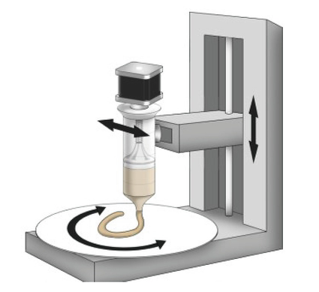

**REQUIREMENTS:**

* System - Windows 7 or higher, 1 GB RAM.

**PROCEDURE:**

**Assembly of Polar 3D Printer**

1. Select 'Assembly of Polar 3D Printer' from the visible list.
2. All the parts related to Polar 3D Printer will be shown on the screen.
3. Select the parts in sequence in which they are shown.
4. When the first part is selected then it will open in the blank space in the left side of the screen.
5. Further, when the correct part will be selected then it will get assembled with the previously selected part/parts.
6. If the user follows an incorrect sequence then a pop-up will appear on the screen showing the name of the part to be selected.

**Playing with Axes**

1. Move the r-axis slider and observe the movement of the r-axis assembly.
2. Move the y-axis slider and observe the movement of the y-axis assembly.
3. Move the z-axis slider and observe the movement of the z-axis assembly.

**OUTPUT:**

|  | Y-Axis Base :The Y axis base on a printer represents movement forward and back. |
| --- | --- |
| Z-Axis Frame :Z-axis frame is responsible for moving the print head up and down. |
| Smooth Rods :In a **3D printer**, **smooth rods** are typically used as part of the **printer's** linear motion system, which is responsible for moving the **print** head and **print** bed. |
| Motors :They help in moving a object to a repeatable position. |
| Extruder Supporter : |
| Threaded Rod :Threaded rods shave off the base material in subtractive manufacturing methods until the desired shape is achieved. |
| Y-Axis Frame :Y axis frame on a printer represents movement forward and back. |
| Motor with Gear :It enables precise movement and positioning in a circular coordinate system ensuring accurate printing along different axes. |
| Motor-with-Pulley :it aids in controlling belt movement enabling accurate printing along different axes.it helps in translation of motor rotation into coordinated formats. |
| Gears :Gears in a 3D printer help regulate motion and control the movement of various components, enabling precise positioning and extrusion of filament for accurate printing. |
| Plate :The printing plate in a 3D printer provides a flat, stable surface for creating objects, ensuring proper adhesion of the printed layers and maintaining dimensional accuracy. |
| Extruder :The extruder in a 3D printer melts and deposits filament, precisely controlling its flow to create the object's structure layer by layer |
| Filament :Filament serves as the raw material for 3D printing, melted by the printer's extruder to form the physical layers of the printed object |

**Fig 1: Assembly of Polar 3D Printer**

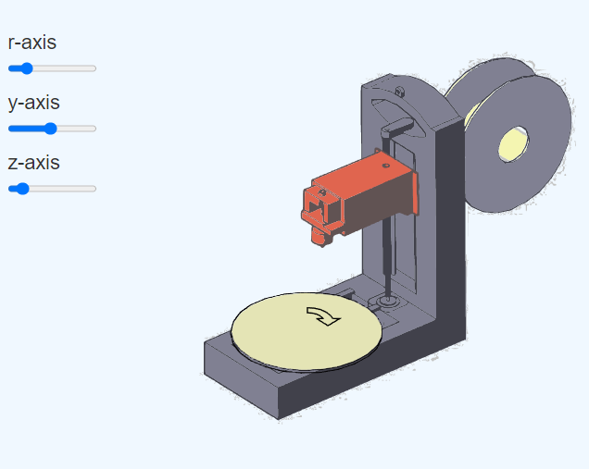

**Fig 2: Playing with Axes**

**Result:** Thus the simulation on construction of polar 3D printer is completed & movement of axis along X, Y, & Z has been studied.